STARCLUB
A STARCLUB is a well-run club where quality coaches and officials work alongside valued volunteers in a safe and welcoming environment.
Why not measure your club against the STARCLUB criteria? You will then receive information and support to gradually build your club so it can provide the best environment possible for your members and the wider community.
Refer to each part to assist with your STARCLUB registration;
PART 1- WELL MANAGED
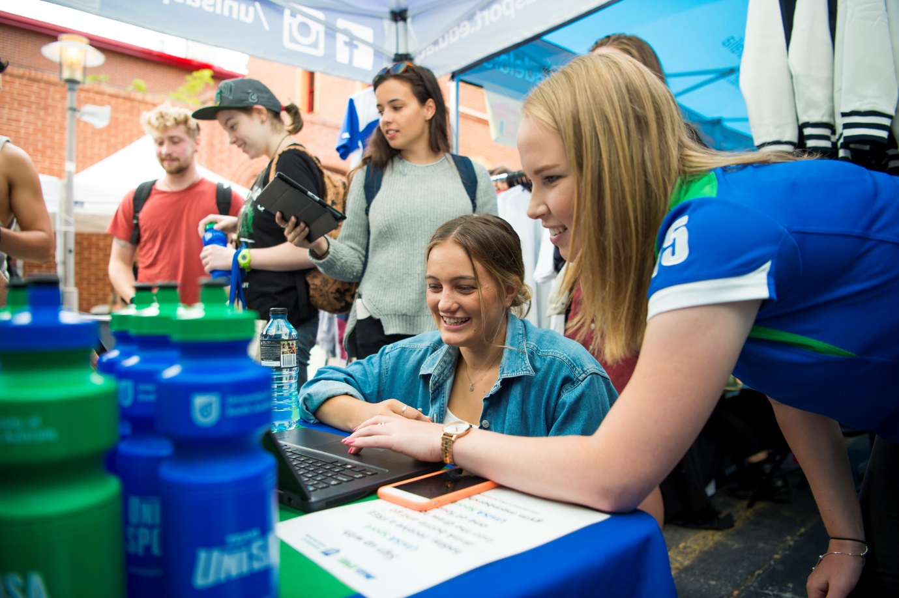
1. Is your club incorporated? Is it well governed?
Incorporation provides a legal identity for a club, separate from that of its members, which relieves the members of the committee and the club from liability for authorised acts of the club.
Instructions for becoming an incorporated club can be found at the Consumer and Business Services website

2. Does your club have a risk management policy to protect participants and volunteers? If the club employs staff, does it have a Work Health and Safety (WHS) policy?
All UniSA Sporting clubs need to put in place strategies to deal with the risks of providing services. If your club is an employer (a PCBU), it is required to operate within the 2012 WHS Regulations. If you only have volunteers at the club, you still have a common law obligation to ensure the safety of all volunteers, a risk management policy will serve a similar purpose.
For a sample Risk Management Policy, please see the link below.
Risk Management Policy Template
As a part of your Risk Management Strategy, a Risk Management Plan should be completed for areas such as:
- Participants safety (Facilities, Equipment & Environment)
- Coaching
- Financial
- Legal / Insurance
- Human Resources (volunteers and paid)
A Risk Management Plan (Risk Assessment) template can be found below:
UniSA Sport Club Risk Management Plan Template
3. Is your club affiliated with the state or national body for your sport?
Joining your state or national body as an affiliate will contribute to the long term future of your club. It will also allow your organisation to enjoy a range of different initiatives offered by your peak body. For further information, please contact your state or national body.
4. Has your club reviewed and updated its constitution and regulations (by-laws) in the past two to three years?
A constitution governs the way a Club is run and needs regular review to ensure that it allows the club to grow and develop with time. Regulations (by-laws) give day-to-day guidance to members on processes and procedures the club has in place to operate. It is vital to review your club’s constitution and regulations regularly to ensure they meet any requirements arising from changes in legislation.
UniSA Sport Club Model Constitution for non-incorporated clubs.
For incorporated clubs the Office of Recreation & Sport have developed a model constitution,
5. Does your club have a strategic document/plan for the next three to five years?
The Strategic Plan of a Club provides a brief snapshot of where the club is aiming to be in two to four years’ time.
UniSA Sport Strategic Plan
UniSA Sport Strategic Plan template
PART 2 – COACHES & OFFICIALS
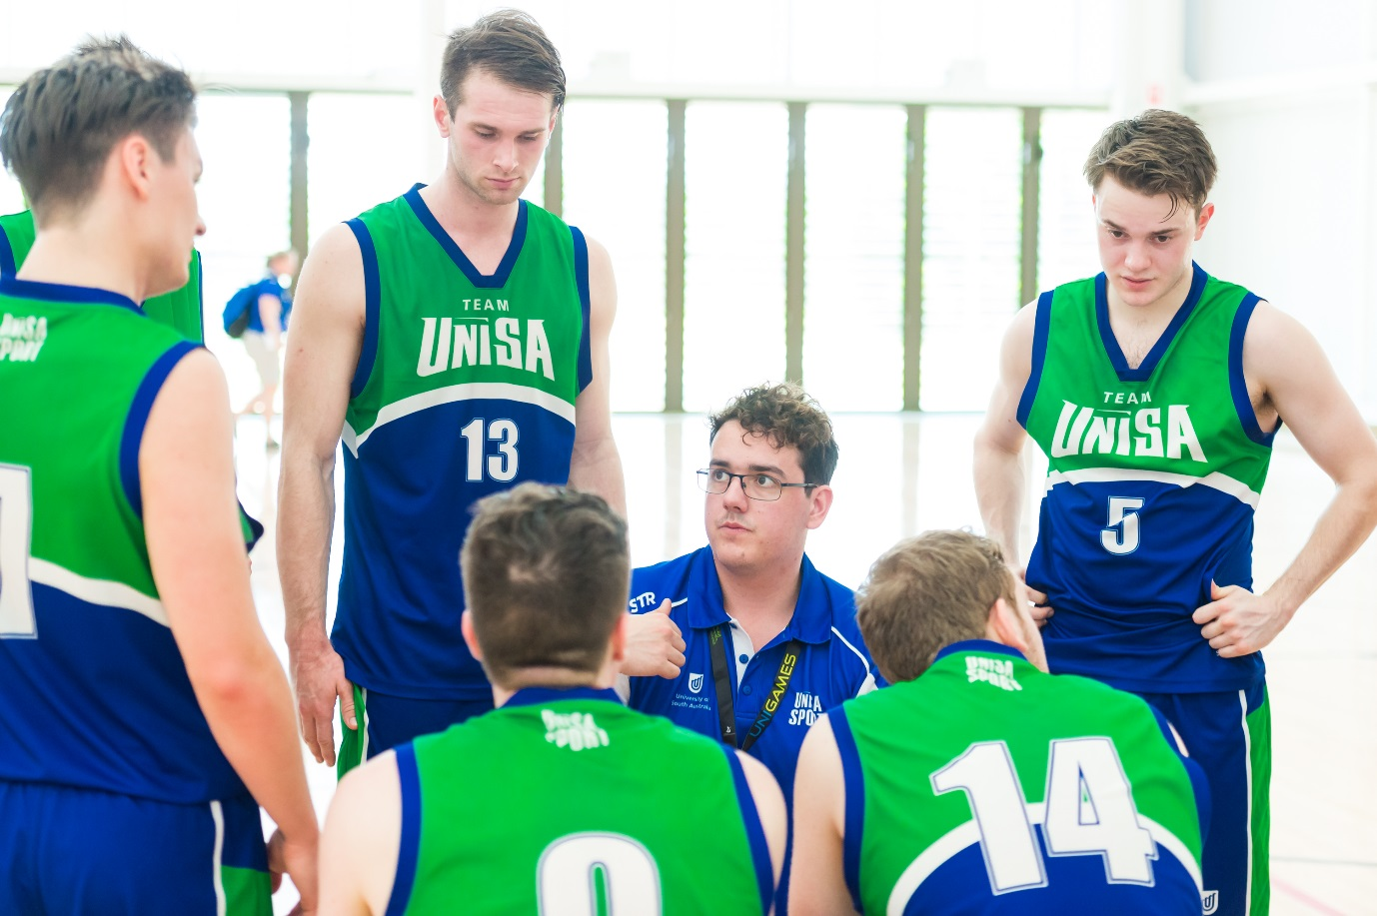
6. Do you support your coaches by providing them with information on available courses and resources for beginner coaches?
General community coaching and officiating courses are offered online through the Sport Australia website and can be accessed free of charge.
Volunteer coaches can be supported through your peak bodies coach/official development courses and qualifications which are focussed on sport specific principles.

7. Does your club use accredited coaches, instructors and officials?
Clubs should be using coaches with a peak body qualification. For further details visit your peak body website.
8. Does your club provide codes of behaviour for all club coaches, instructors and officials to abide by?
Codes of behaviour should be used to clearly state your club’s expectations of players, coaches, officials, volunteers, parents and spectators.
UniSA Sport Code of Conduct

9. Are sideline trainers (or First Aid officers) in attendance during club training sessions and matches?
It is recommended that all clubs have a qualified first aid officer at the club for matches and training sessions. Qualified coaches should have a valid first aid certificate as part of their qualification, as will people in many other professions.
Why not check with players and coaches if they have a current first aid qualification and if they are willing to be the nominated first aid officer for the period they are at the club?
For volunteers; committee members, managers, coaches and/or officials looking to gain a first aid qualification, UniSA run a First Aid course annually in April, run by an external provider.
Additional providers that run First Aid courses are:
Australian First Aid
St John Ambulance Australia
Australian Red Cross
10. Does your club subsidise course and travel costs for coaches, instructors and officials?
Some training courses are expensive and good clubs assist their volunteers to meet the cost of training. Funding to support training of coaches, instructors, sideline trainers and administration officials at your club is available through several sources including:
Office for Recreation and Sport Grants
Office for Volunteers Grants
Local Council Grants – a variety of grants are available through local councils. Contact your local council direct for more information.

PART 3- VOLUNTEERS MANAGED
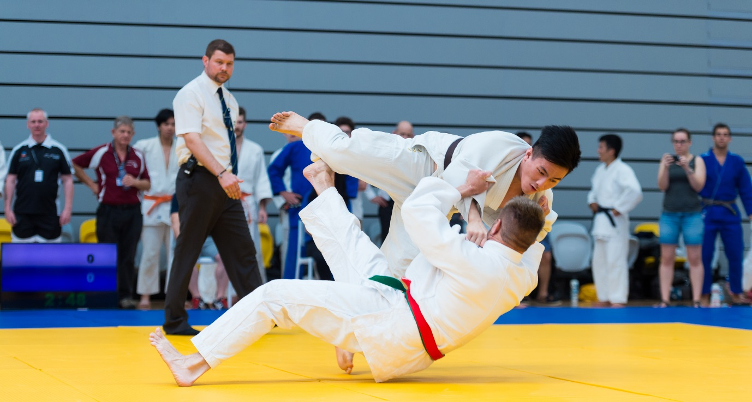
11. Does your club provide its volunteers/staff with induction information?
Good clubs give volunteers and staff clear guidelines for their roles and responsibilities and a briefing on policies, procedures and guidelines that apply to them, especially those working with children. Volunteers and staff have legal obligations to report suspected incidents of child abuse that they may observe in their roles, and the club needs to make them aware of this obligation.
Specific Guidelines that relate to UniSA Sport endorsed and affiliated clubs are:
UniSA Sport Club Affiliation and Endorsement Handbook
UniSA Sport Club Branding and Uniform Guidelines
UniSA Sport Child Safe Environment Guidelines
UniSA Sport Club Critical Incident Procedure
UniSA Sport Club Facility Access Guidelines
UniSA Sport Club Membership Policy

An induction manual template for volunteers can be found below:
Volunteer Induction Manual Template

12. Does your club have a volunteer/staff management policy in place?
Good clubs will have in place a written volunteer management policy. This helps show the club’s commitment to finding, keeping, and backing the best people. A volunteer coordinator position may help your club manage and retain your volunteers and their accumulated skills and knowledge to pass on to others.
Please see the Volunteer Management Plan Template below:
Volunteer Management Plan
13. Does your club recognise and reward its volunteers/staff?
Volunteers need to feel valued. Recognising and rewarding their efforts will be appreciated and is important when encouraging volunteers to continue in their roles.
There are many ways to recognise and reward volunteers. Some are free and very simple and others require a lot of planning and cost money. The template below will provide you with many ideas.
Volunteer Recognition Ideas Template
14. Are young people encouraged to take up leadership roles in your club?
In general, young people are full of fresh perspectives, enthusiasm and ideas. If you have youth members in your club, talk to them and find out what would entice them to volunteer. If you are unfamiliar with the latest technology, speak to the younger members about them helping in this area of your club. Volunteering can help youth add value to their CVs, complete academic subjects and obtain scholarships (such as the Duke of Edinburgh Award).
For UniSA undergraduate students, the University has a leadership program, UniSA+ which recognises and rewards students who have achieved activities under the three pillars; Leadership & Enterprise, Global & Social Engagement and Self-Development. For further information about UniSA+ go to the UniSA website
Use these as incentives for this group.
15. Does your club have a succession plan?
To keep your club active and growing, the organisation needs to plan for the time when key people move on. This is particular prevalent in University clubs where there is a high turnover of committee members due to the time students are at University. Having a succession plan in place to support and develop people to take over key roles ensures the club stays strong and grows with time.
Tips on preparing a succession plan
Volunteer Handover Procedures
PART 4 – POSITIVE & WELCOMING
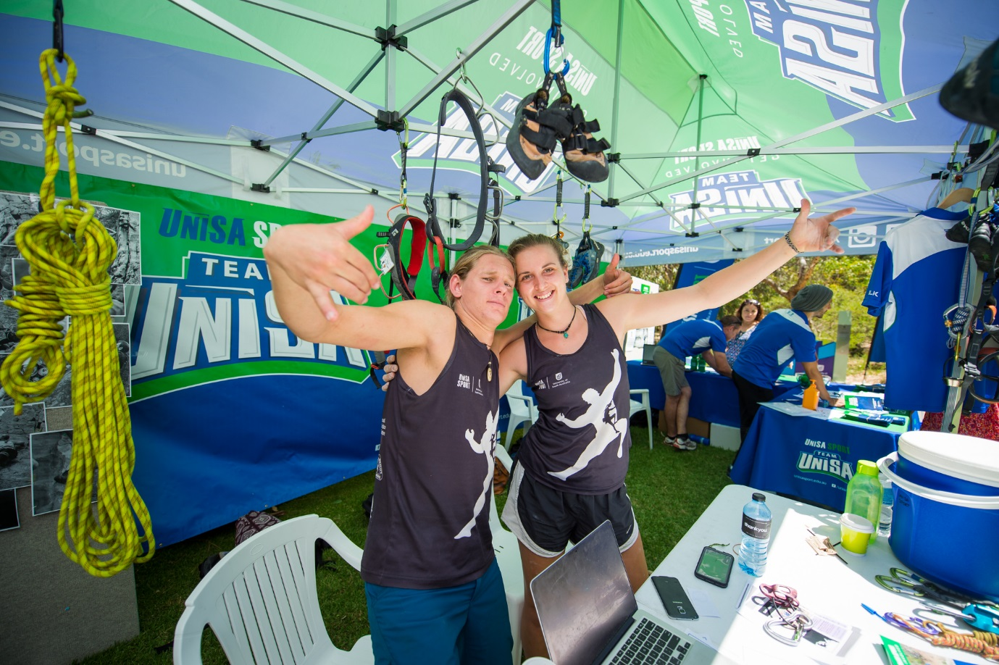
16. Does your club comply with Equal Opportunity (EO) principles?
As an affiliated club, you are expected to abide by the UniSA Sport Protection Member Policy and the UniSA Sport Equal Opportunity Policy.
17. Does your club treat people from all cultural backgrounds fairly and with respect?
Good clubs encourage all members of the community to become involved with the club and provide a welcoming environment for everyone. The club is committed to ensuring that all people, regardless of their cultural background and ability, have equal access to sport and recreation opportunities. Good clubs also consider how their off-field behaviour, such as their social functions, can reflect this openness.
For more information on cultural diversity training, please click here.
18. Does your organisation manage the behaviour of its supporters and spectators?
Codes of behaviour should be used to clearly state your club’s expectations of players, coaches, officials, volunteers, parents and spectators. All clubs are expected to abide by the UniSA Sport Code of Conduct for these parties.
Clubs affiliated with peak sporting bodies should be aware of their Code of Conduct.

19. Does your club provide options for members experiencing hardship?
Good clubs show commitment to their potential and existing members through good and bad times and find that commitment is reciprocated. Consider offering loaned equipment, uniforms and reducing fees. All affiliated UniSA Sport clubs should be offering reduced fees to UniSA Sport students.
Consider also allowing members that are experiencing hardship to have their membership fee waived if they bring on board a sponsor for the club. A suggested arrangement would be to have the value of the sponsorship at least twice that of the membership fee. This way, the club gains money from the sponsorship as well as allowing the member to play. Members experiencing financial hardship could also take on a coaching/managing role if they are suitably qualified in return for payment of fees.
20. Does your club have processes in place to deal with complaints or conflict?
A good club is well prepared to deal with complaints and issues that may arise from incidents of harassment, discrimination, bullying or abuse. Procedures need to be in place to prevent situations getting out of control and causing long-term damage to the club and its members.
As an affiliated club, you are expected to abide by the UniSA Sport Member Protection Policy and Code of Conduct. Processes to deal with complaints or conflict are covered in this policy.

PART 5 – SAFE FOR ALL
21. Does your club comply with its legal obligation to provide child safe environments?
All recreation and sport organisations are subject to the Children’s Protection Act 1993, so good clubs have developed policies and procedures to establish and maintain child safe environments.
Your obligations as an affiliate or endorsed club of UniSA Sport are outlined in this document:
UniSA Sport Child Safe Environment Guidelines
UniSA Sport will fund 1 person from each club annually to complete a DCSI Screening. Additional screenings will need to be covered by the individual or club.
To assist in meeting these obligations, the following links provide necessary information:
Information on obtaining a DHS Child Related Employment Screening
Upcoming training opportunities for Child Safe Officers and other volunteers
Mandated reporting of child abuse

22. Has your organisation appointed and trained a Child Safe Officer?
A good club will have access to a trained Child Safe Officer who can assist in making new volunteers, staff and participants aware of their rights and responsibilities. Training is free, and provided by the Office for Recreation and Sport to help your club provide a ‘child safe’ environment.
More information on the role of a Child Safe Officer and the free training available
23. Does your club promote ‘Play by the Rules’ online training?
Good clubs promote ‘Play by the Rules’ online training for coaches, officials, administrators, parents and participants. Free online resources and training are available to make sport inclusive, safe and fair. Completion of the training supports your club’s member protection policies and will keep your members well informed and up to date.
24. Has your organisation adopted a hot/extreme weather policy?
Sports Medicine Australia provide guidelines on hot weather policies for clubs
Please also check with your state or national body, as they may have a policy in place for hot/ extreme weather.
25. Does your club promote a positive, drug and alcohol-free junior sport environment?
Whether your club has a liquor license or not, it is important that all members, particularly young people, can enjoy an atmosphere where alcohol is managed in a responsible and considered manner.
The Good Sports Program offers a simple but effective three-step accreditation process to improve the way alcohol is managed at sporting clubs.

